International Academy Website Re-design

Project Report

Date: 26-02-24

1. Abstract
2. AIM/REQUIREMENTS
3. Introduction
4. Modules and its functions(USERS)
5. Wireframe
6. Design Justification
7. Conclusion

ABSTRACT

Today the Company functions in Cochin, Kottayam, Trivandrum, Kollam, Angamaly, Thodupuzha, Thrissur, Calicut and Kannur India. Besides we have office in Toronto, Canada, Canberra, Australia and Auckland New Zealand.The International Academy in the online service patform with help the student and individuals to insight the future goals by different services .The services are Study abroad program, Coaching, Training and language problems with scholarship. Here my aim is to redesign the existing website .I first analyze the working of the International Academy by following website .The website is seems like complex and design was too unfair to user to navigate the understanding of working or coordinate with websites,I arrange the section by priorities to the customer needs .Here I uses the HTML,CSS, for the development of Homepage of IA.The project was started in Feb 26 itself . The project was assessment test for the selection of UI/UX designer on UFS Technologies PVT LTD.And I am happy to work with the project because it enrich to idea and knowledge in UI/UX designing.

AIM/REQUIREMENTS

**Task Requirements:**

* Selection of Sections: Choose wisely the sections for the homepage that you believe would benefit significantly from a redesign. Please provide a brief rationale for your choice.
* User Research: Outline your approach to understanding the users of the International Academy website and how this informs your redesign.
* Wire framing: Develop wireframes for your proposed redesign, showcasing the layout and basic user interaction concepts.
* Design Justification: Prepare a brief document or presentation that explains your design decisions, focusing on how they improve user experience and address user needs.

INTRODUCTION

The International Academy (<https://www.internationalacademy.in/>) started its operation in January 2001 with 'Head Quarters' in Cochin, Kerala, India. Today the Company functions in Cochin, Kottayam, Trivandrum, Kollam, Angamaly, Thodupuzha, Thrissur, Calicut and Kannur India. Besides we have office in Toronto, Canada, Canberra, Australia and Auckland New Zealand. Mr. Tyju Thomas is the director for International Academy, India Operations.

We also function across the globe and deliver Study, Work , Immigration and Coaching programs through our branches and dedicated online team. International Academy provides effective coaching for IELTS, OET, PTE, TOEFL, French and also provides training for Nurses License Examination to Abu Dhabi, Dubai, Qatar, and Saudi, the USA, the UK, Canada, Ireland and Singapore. Globally International Academy is known as Headers International Academy and Mr Talu Thomas ( Christy Thomas) is the Global Managing Director for the company.

We offer study abroad guidance to the UK, Ireland, Australia, New Zealand, The U.S.A, Canada, Europe, Singapore, and Malaysia. Besides assist immigration to Canada, Australia and New Zealand. Our immigration division is unique by providing Canada, Australia and New Zealand immigration service by a single consultant.

International Academy is a top ILTS, TOEFL,OET ,PTE Training Center and Offer Regular, Part Time and Online Classes. We Offers Licensed Immigration Services To Canada , Australia and New Zealand and Offers and also Study Abroad Guidance through our Division "HEADERS”. Besides, We Provide all kinds of Visa Application Assistance to Various Countries and Serve Clients Globally through our Offices in Canada , Australia , New Zealand and India.

Modules and its functions (USERS)

By the analysis phase I understand that each and every member who want to enrich the career in advance can visit the site .And who want training in language ,Higher exam like top ILTS, TOEFL,OET ,PTE can make better understanding about the process. IELTS Training TOEFL Training PTE Training OET Training French Training Communicative English Training And take small step from the academy,Immigration,Visa etc .

The Modules:

1. Students
2. Immigrates
3. Visa Members
4. Individual who can share the ideas about Immigrates, Visa ,Coaching through websites

WIREFRAME

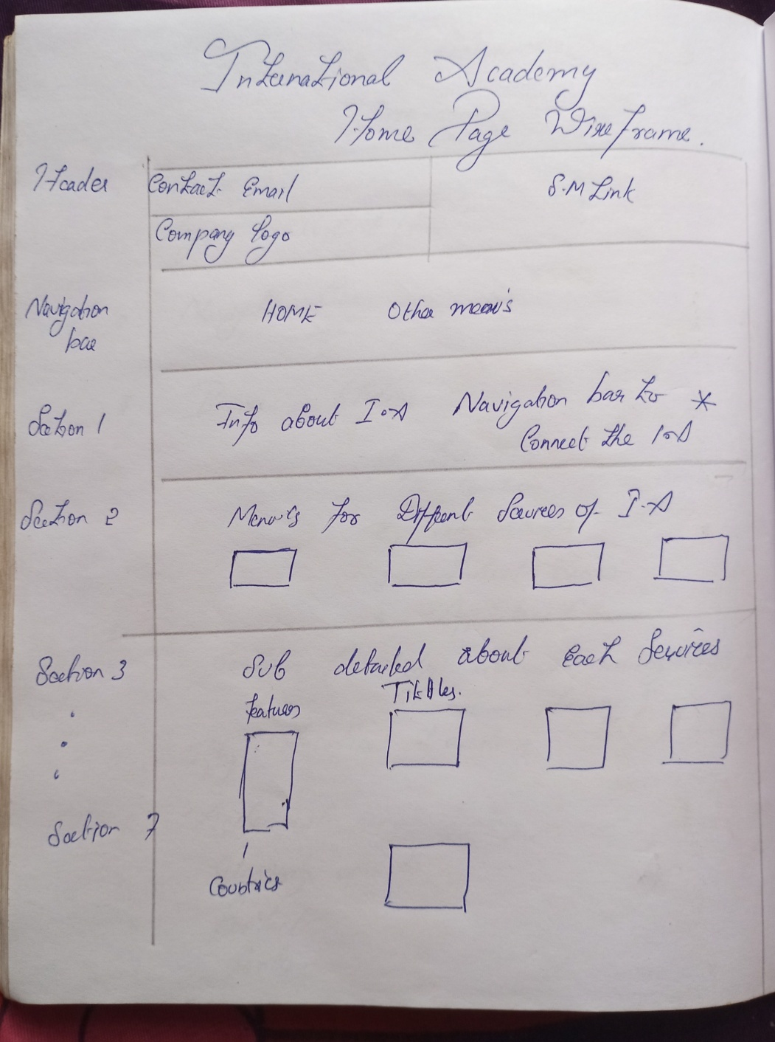

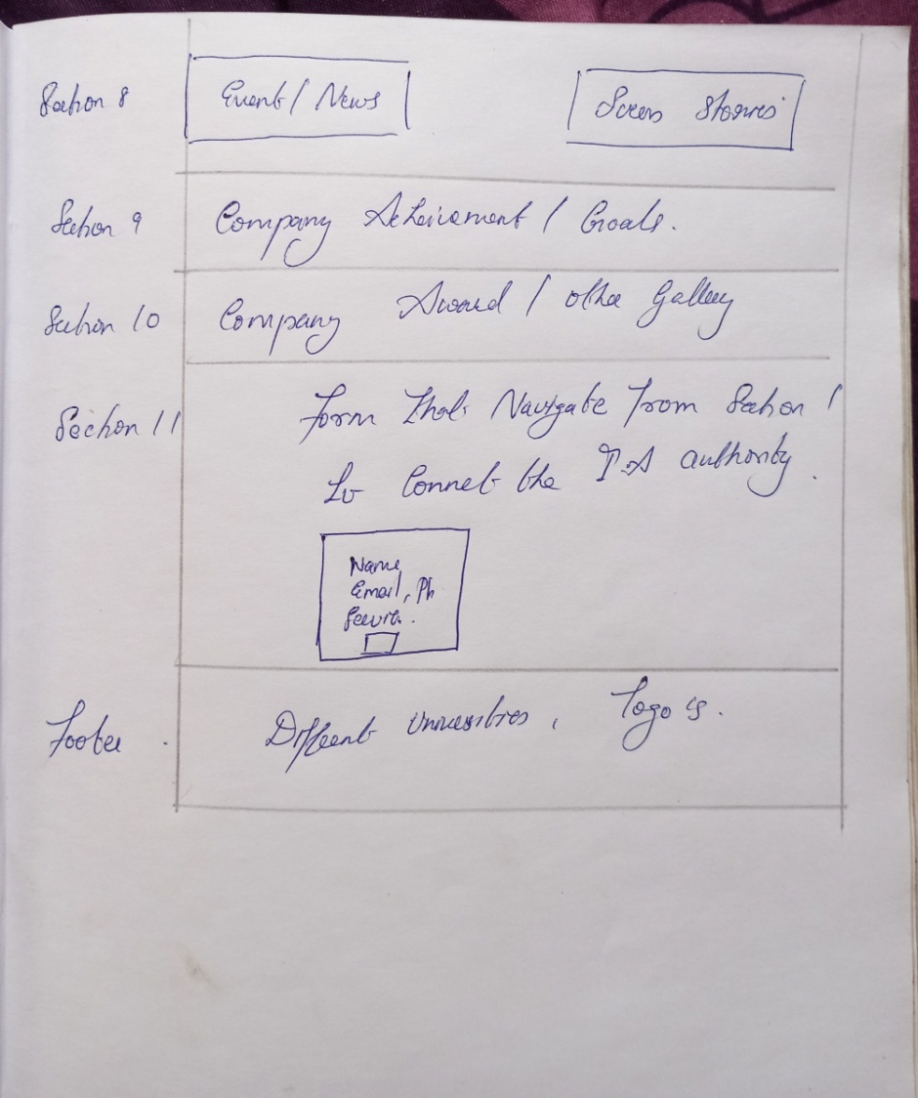

DESIGN JUSTIFICATION

The existing website was too good and attractive but the arrangement of section was not attractive to the user to interact with the website the color grading and style does not fit with the educational sites. The website does not provide better understanding about the duties, service by the International Academy. The navigation bar and header provide inactive visual in existing website. I gave attractive icons to the new websites, with each function drop down icons. I gave attractive the form to connect the International Academy with proper Labels. I added the the prper segmentation and alignment for the website in different sections.

* First of all the welcome page or homepage starting with basic understanding about the sites and goals and missions
* Add good touch with the authority by adding or attaching the Touch or connect with us button that navigates to bottom from .It gave more attention for other areas too.
* Add proper designs for events ,latest news by arrange it in proper segments and styles
* Add each and every services of academy such as coaching ,Training etc.
* I gave proper navigation and roadmap to the user who interact with sites

Home Page

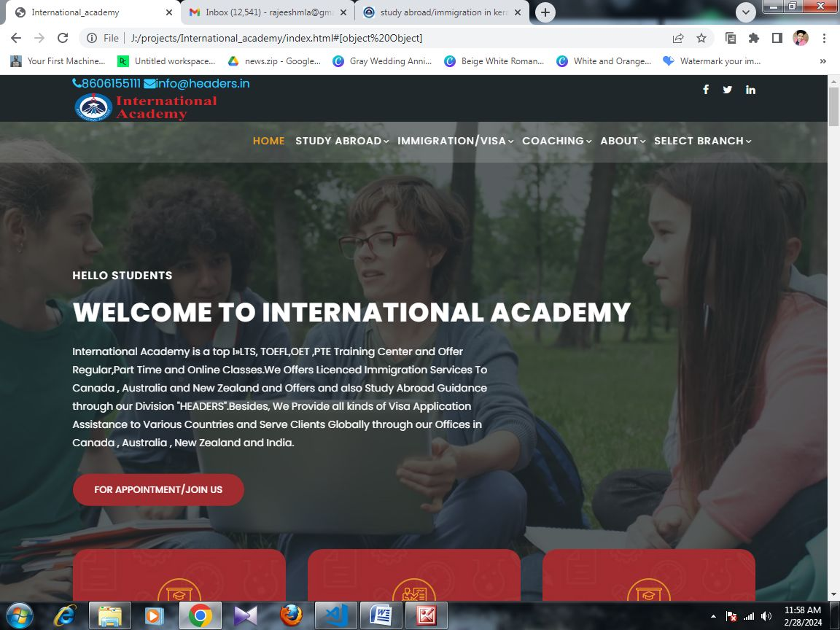

HOMEPAGE-SERVICES

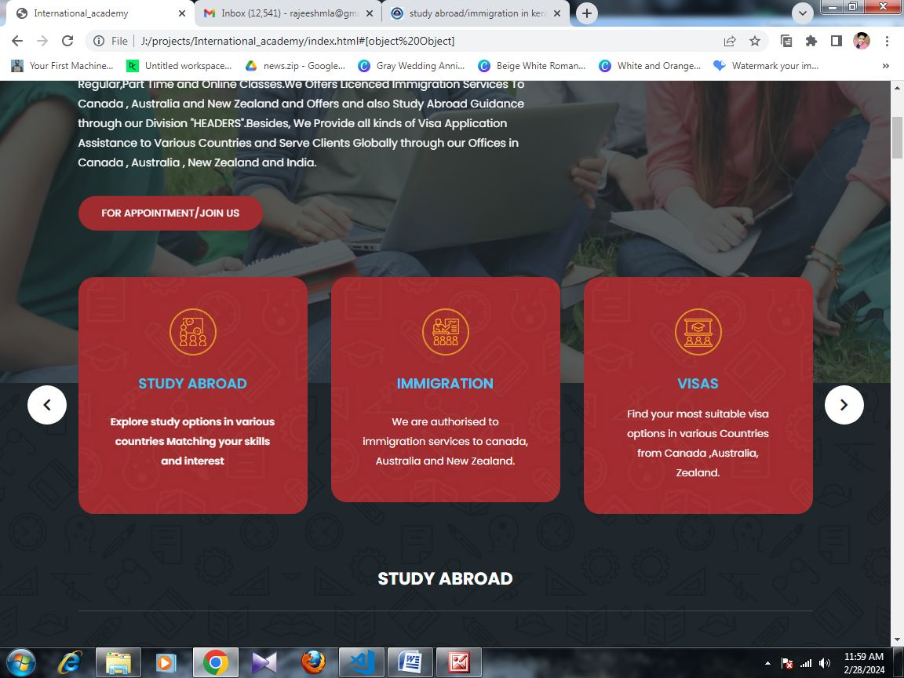

HOMEPAGE-STUDY ABROAD

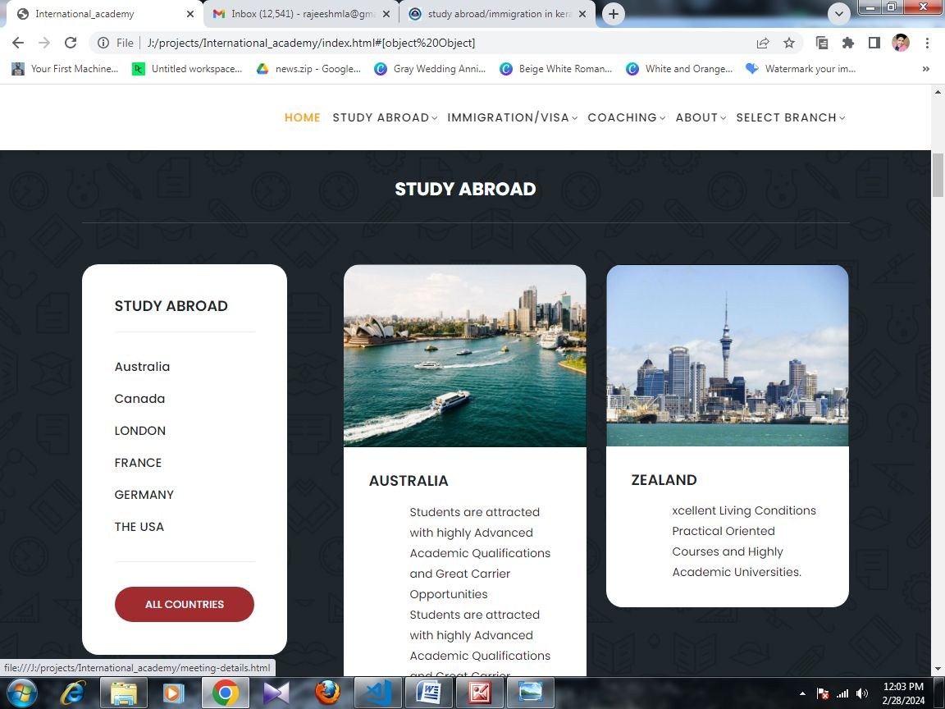

HOMEPAGE-IMMIGRATION

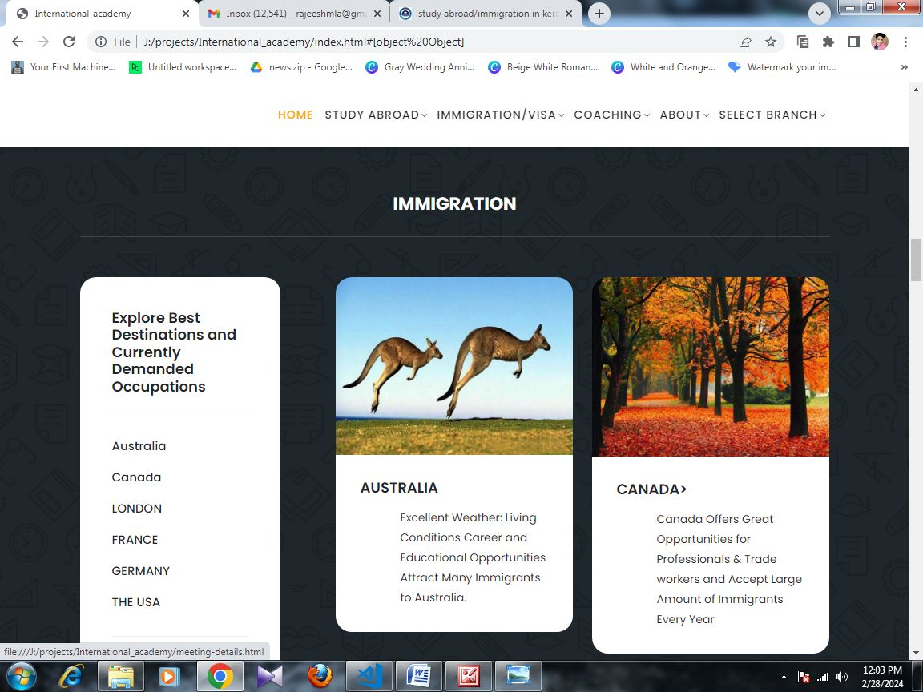

HOMEPAGE-Events and News

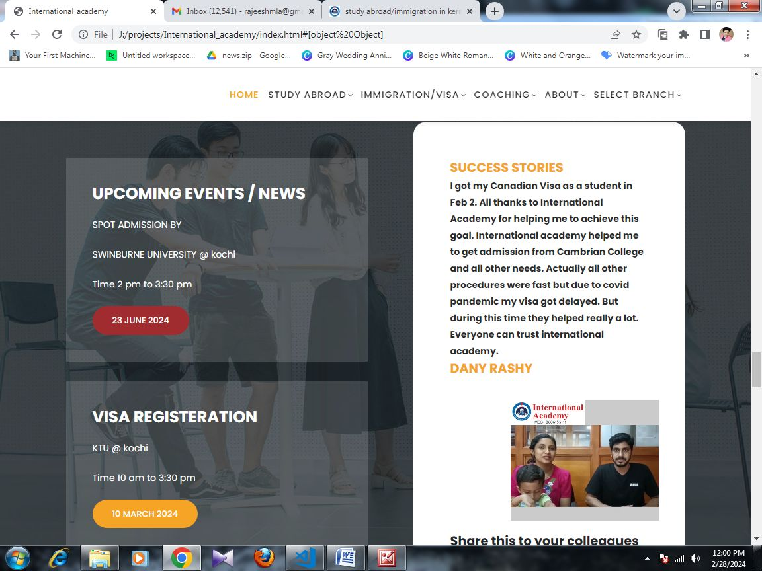

HOMEPAGE-AWARD

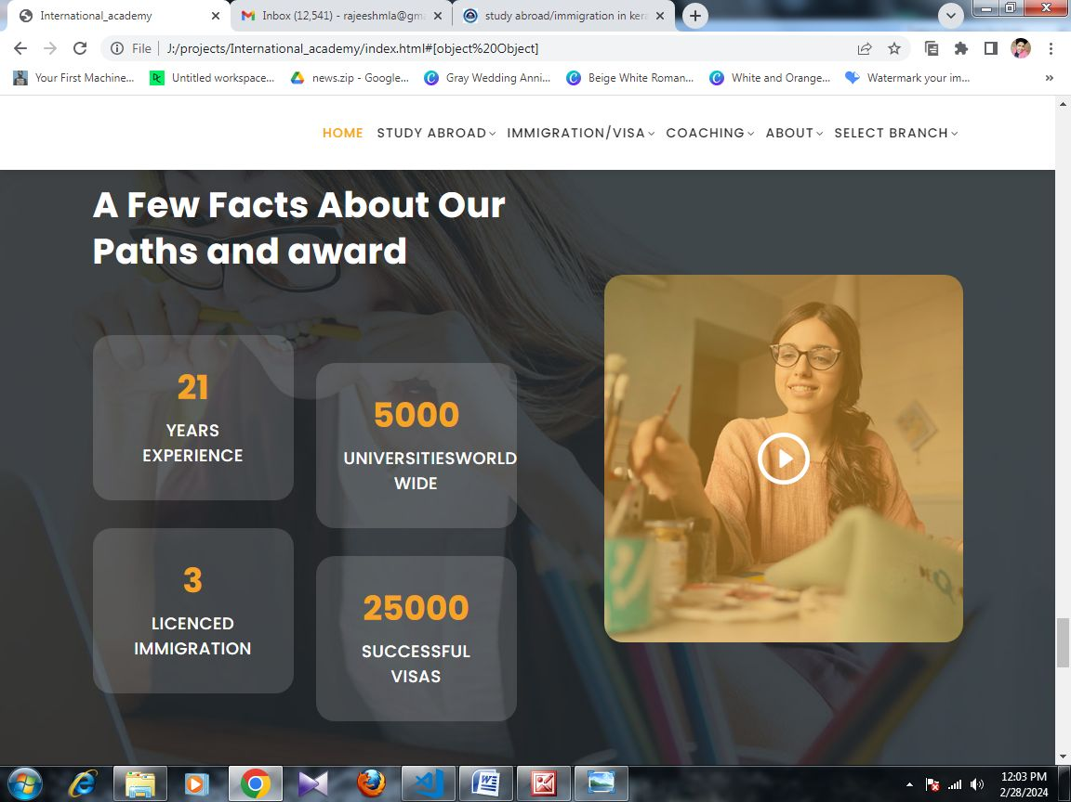

HOMEPAGE-CONNECT WITH ACADEMY

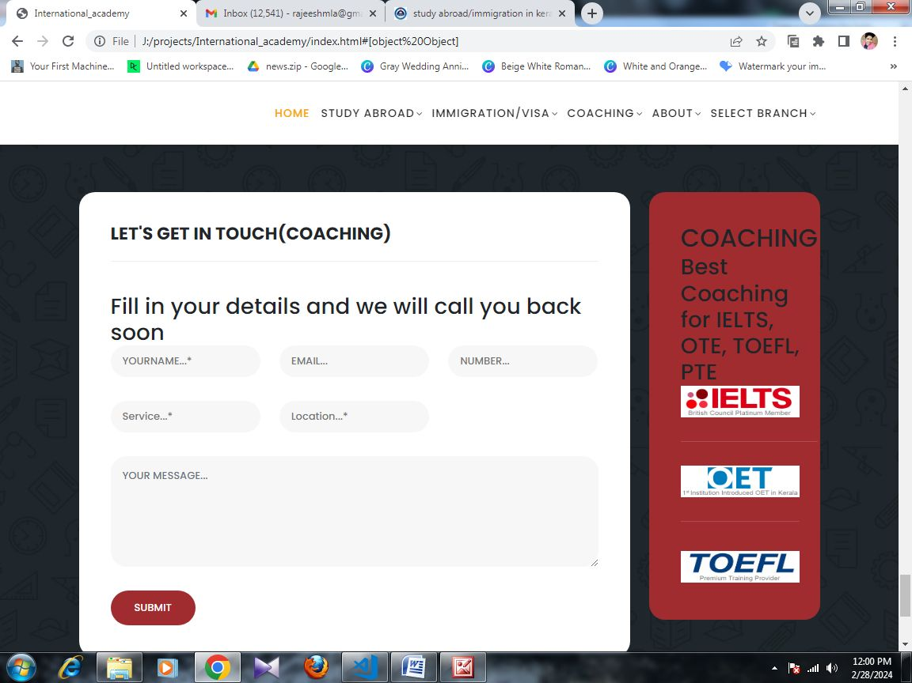

CONCLUSION

The project was nice and it increases by knowledge as well as idea to develop a website related to education sectors. The International academy provides different service to society in build the career goals and achievements to students, Visa, Immigration etc. We also function across the globe and deliver Study, Work , Immigration and Coaching programs through our branches and dedicated online team. International Academy provides effective coaching for IELTS, OET, PTE, TOEFL, French and also provides training for Nurses License Examination to Abu Dhabi, Dubai, Qatar, and Saudi, the USA, the UK, Canada, Ireland and Singapore.The website was developed in fascinating and attractive manner to understand the user to proper roadmap about the websites.